Intellica Coding Standards

Intellica Corporation
209 W. Poplar
San Antonio, Texas 78212

02/02/2012

Table of Contents
No table of contents entries found.

Naming Conventions
We use a modified version of "Hungarian notation" for naming application variables. The Hungarian naming convention is one technique that helps developers produce better code faster. The idea is to precede variable names with a value that identifies the variables type and to capitalize the first letter of each noun or verb in the variables name. Below is a listing of prefixes and types. In addition to this, all constants are identified using all capital letters.
Variable naming conventions:
C#
Prefix Type Example
ar array arstrSplits
b boolean bPatientLoaded
cds CDataSet cds
dt DateTime dtToday
pList CDataParameterList pList
chr char chrPipe
ds DataSet ds
dbl double dblItemPrice
l long lUnitID
n integer nNumItems
sb StringBuilder sbScript
str string strLastName

HTML/ASP.NET Controls
Prefix Type Example
anc anchor ancToDate
btn asp:Button btnSubmit
btn asp:ImageButton btnPrev
btn asp:LinkButton btnHome
cbo asp:ComboBox cboOptions
ddl asp:Dropdownlist ddlOptions
chk asp:Checkbox chkAgree
ct asp:Content ctReport
div div divOrderBy
gv asp:GridView gvInfo
htxt asp:Hidden htxtList
img img imgBanner
img Image imgTab
lbl asp:Label lblWarning
mvw asp:MultiView mvwChiSquare
pnl asp:Panel pnlSearch
tbl table tblOutput
txt asp:TextBox txtFirstName
uc User Control ucDateRange
lit Literal Control litHTML
mnu asp:Menu mnuMain
tsm Toolkit Script manager tsmMain
up Update Panel upSearch
cph Content Place Holder cphMain

The following table contains letters that can go before the above prefixes:
Prefix Description Example
m_ member variable m_strLastName
k_ constant k_strLAST_NAME
Class naming conventions:
All class names begin with a Capital letter "C" followed by capitalizing the first letter of each noun or verb in the class's name. Examples: CPatient, CPatientName, CPatientLab. The only exception is Visual C++ COM wrapper classes. Classes can begin with an underscore instead of a capital "C" and follow the convention above. Example: _Patient
Database field and table naming conventions:
Database table names and field names should be capitalized and separated with an underscore ("_").
Examples: PATIENT_LABS, STAT_SEX, FX_USER, FIRST_NAME
We use several table name prefixes to group tables together as follows:
STAT_ = Static data that stands on its own
USR_ = Data that is modified by application users
UTL_ = Data that is modified by application admin/utility users
FX_ = Framework tables used across multiple applications
Web Page Naming Conventions:
Individual web page names are separated with an underscore ("_").
Examples: employee_alerts.aspx, employee_tbhighrisk.aspx
Stored Procedure Naming Conventions:
Package Naming Convention: All package names begin with “PCK_...”

Example: PCK_COMMAND_READINESS, PCK_AUDIT
Procedure Naming Convention: All procedure names begin with “PRC_...”
Example: PRC_TB_ICDB_APPOINTMENT, PRC_TB_MEDBASE
Procedure Naming Convention: All function names begin with “FNC_...”
Example: FNC_TB_HIGHRISK
However, since some functions in Oracle are used in SQL statements, you may not follow the naming convention guideline.
Examples: isTbRead(), IMR_Date_Created(), is_Numeric()
Variable Naming Convention:
Variable name consists of declaration type, variable type, and variable name.
1. First prefixes for variables are determined by the declaration type of variables:
Input parameter: pi_...
Output parameter: po_...
Local variable: v_...
Constant: c_...
2. Second prefixes are determined by the type of variables:
Varchar2: …v…
Char: …c…
Number: …n…
Date: …d…
Boolean: …b…
Long: …l…
Clob: …cl…
Blob: …bl…
Raw: …r…

Examples: pi_nPatientID,
pi_vUserName,
po_dTbDateRead,
po_vTbReadBy,

v_vAuditUser,
c_vAuditSchema,
c_nStatus_Error

Oracle SQL Statements

For security reasons all SQL statements executed in stored procedures must be dynamic SQL and must be executed by using bind variables. SQL Statements using bind variables are immune to SQL Injection attacks as the Oracle database will use the value of the bind variable and not interpret the contents of the variable. Bind variables must be used for both security and performance reasons. The actual SQL statement with the bind variables must be declared as a constant in the “is” block.

Examples:
…
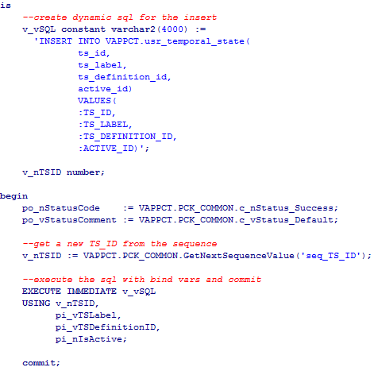
…
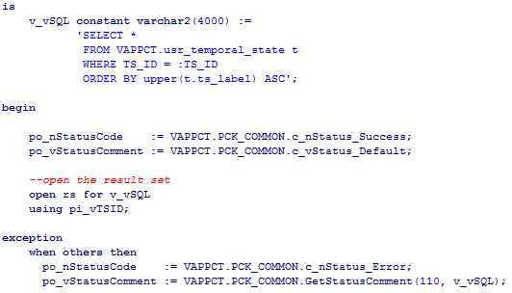

Oracle SQL “into” Clause

Retrieving a single value into a PL/SQL variable using a SQL “into” clause is done by calling PCK_COMMON.GetDynamicSQLValue function.
Oracle Sequences

Retrieving the next value from an Oracle sequence must be done by calling the PCK_COMMON.GetNextSequenceValue function.

Example:
…

Oracle Stored Procedure Error Handling

The PCK_COMMON package contains constants for returning status information from a stored procedure call. These constants must be used to set the po_nStatusCode output parameter as follows.

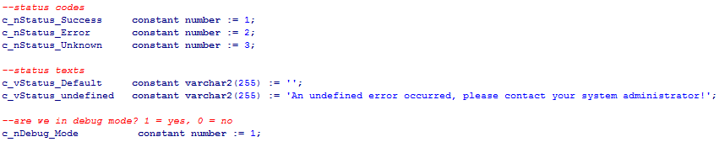

…
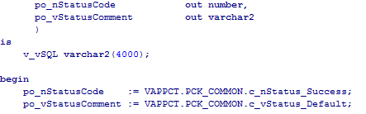
…
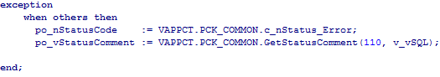

All status comments/error messages must be stored in the stat_pck_status table and must be returned to the caller by using the PCK_COMMON.GetStatusComment function.
Error messages must be “User Friendly” and not contain any security related information.
Debug information can be passed in as the second parameter to the function call, and if the c_nDebug_Mode constant is set to 1, this information will be displayed along with the status message.
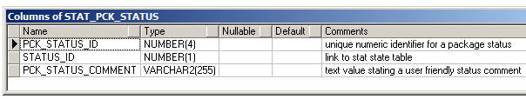
Example:

Unsafe Functions

Any functions in the .net library that directly write to the file system are also considered “unsafe” and not allowed in software written in ASP .net / C#.

Web Application Design

A user interface is basically a presentation layer of some sort of model-data. There could be more than one view of a data model. The Model is the representation of the real-world item the user is trying to interact with. It typically holds the data and business rules. The View pulls information from the Model and renders that information in a way the user will understand. The Controller interprets actions by the user and sends the information to the model or the view. The model knows nothing about the view or the controller other than that they exist. The advantage to this type of architecture is that the view and the controller may be changed without affecting the model.

A Dataset contains the application data and represents the Model component. Separating the data (Model) from the actions performed on it (Controller) allows us to design a system independent of which back end happens to be used to store the data. A developer creates a View by developing the user interface in an ASPX page. The Controller functions are implemented in the code-behind file for the ASPX page (.aspx.cs). Separating user display (View) from actions (Controller) promotes code reuse.

We use ASP.NET master pages to create a consistent look and feel across the application. In addition to this, all of our master pages derive from a single base master page. This base page contains common functions that are used across all pages. It also acts as a central controller for security, auditing and page flow.

Web Based Applications Security and Privacy

Authentication

For web applications using CAC cards and Forms-based authentication, user accounts are created and stored in the Oracle database. An account is associated with a CAC card the first time the user logs in and changes their initial password. Passwords and CAC information are encrypted before storing in the database. Credentials will be passed only over a secure connection using SSL. Unauthenticated (or Anonymous) users are denied access to all resources except those needed to login. Current procedures for passwords, account expiration and lockout will apply.

TBD VAPPCT

Privileges

HIPAA requires that users should see the very least amount of a person's protected health information (PHI) that is necessary to do their job. We ensure compliance with HIPAA regulation by developing a privilege based access to our application. Access to each page in the system will require that a user have a specific privilege to view the page. The users navigation options and page access will change based on the privileges they have.

Auditing

Audit trails in information systems are one of the best ways to track access to HIPAA protected health information (PHI). General auditing is built into the application data layer. Every time an Oracle Stored Procedure is called the parameters are packaged up as XML and saved to the FX_AUDIT table. All user actions and database actions will be audited. Auditing can be turned off or on by a setting in the web.config file. Other types of auditing may be built within the application as needed.

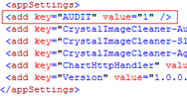

Session State Management

Session state is managed by using the IIS session id and Oracle database stored procedures. When a user successfully logs into the system a session record is created in the oracle database. This session record contains a unique session id that is different from the IIS session id and the unique user id of the person that logged in. This database session record along with the IIS session ID is used to authenticate the user for the duration of the session. On every page load, the user id is retrieved from the database using the database session id that was created when the user logged in.

Application Session Timeout

For security reasons web applications will timeout after 20 minutes of inactivity. This timeout can be adjusted by changing a setting on the web server. In addition to the default time-out, each user can also have a timeout defined based on their role. This timeout value is stored in the database and retrieved when the user logs on.

Encrypting connection strings in web.config

ALL database connection strings in the web.config file must be encrypted using the aspnet_regiis tool.

Change directory to: windows\microsoft.net\framework\v2.0.50727\

Run the following command:

aspnet_regiis –pef “connectionStrings” “e:\websites\vaepi” –prov “RsaProtectedConfigurationProvider”

Open the web.config file and make sure the “connectionStrings” section is encrypted.

Web Application Model Components

As stated earlier, the Model is the representation of the real-world item the user is trying to interact with. It typically holds the data and business rules. General Data Access components will be developed as a set of C# classes inside of a separate C# library component. All model classes will access data via the General Data Access C# library. The model classes used directly by ASP .NET pages will be created in the App_Code directory of the ASP .NET web project.

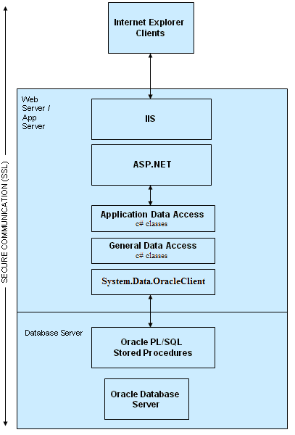

Web Application General Data Access C# class library (DataAccess)

This library contains tools for connecting to Oracle. It also contains tools for passing parameters to Oracle stored procedures and retrieving DataSets. ALL data will be accessed via Oracle stored procedures through the Data Access components. This will simplify auditing and centralized data access business rules as well as connection to data sources.

Web Application Model Classes

Model classes will use the General Data Access classes to insert, update and retrieve data to and from the database. Methods in the model class will return bool to indicate success or failure. Additional information will be returned in the out variables ds, lStatus and strStatus where ds is a .NET DataSet, lStatus and strStatus are the status code and status text returned from the stored procedure call. A status code of 1 means success, a code of 0 means the call failed and a status code of 2 means the call failed for an unknown reason. The status comment will contain status information in a “user friendly” format. Our BaseMaster class will display status information at the top center of the screen.

Examples:
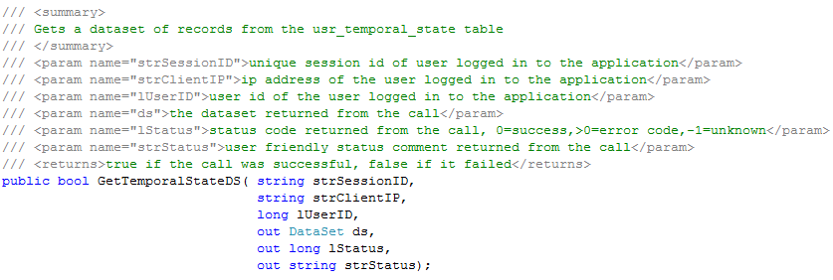

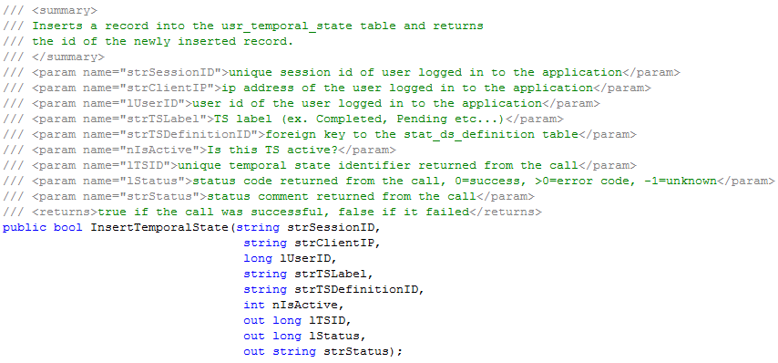

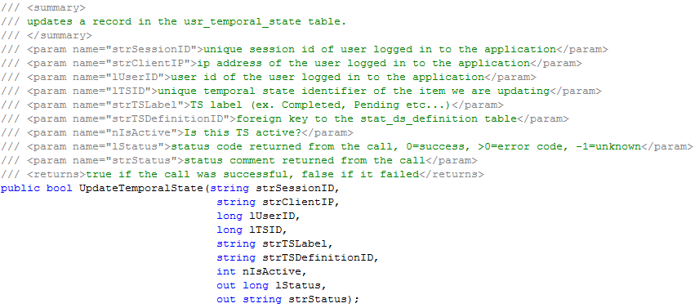

Web View Components

View components are basically a presentation layer of some sort of model-data. There could be more than one view of a data model. Views are implemented by developing the user interface in an ASPX page. The Controller functions are implemented in a code-behind file for the ASPX page (.aspx.cs). The use of Web User Controls is encouraged if the same functionality is to be used across multiple pages.

Web Controller Components

By having all of our code-behind pages inherit from a common base master page, we can place all of our pre-processing and security checks in one place. This allows you to verify access to the page and perform any redirecting in one central location, similar to what a Central Controller would do. Our base master page class is named BaseMaster.cs

Web Session State

Session data is specific to a particular user. It lives for as long as the user continues to makes requests plus some period of time afterward (typically 20 minutes). The Session object can hold large or small amounts of data, but total storage should be kept minimal if the application is intended to scale to hundreds of users or more. No HIPPA data is permitted to be cached in web session state.

Web Error Handling

All calls to the DataAccess layer/Model components will return status information. A status code and a status comment will be returned from each call. Our BaseMaster class will display status information at the top center of the screen.

Source Code Comments

Comments are required above each method and encouraged throughout the source code. Comments are especially encouraged near complex blocks of source code.

Source Control

All source code is managed using Bazzar. Developers are responsible for ensuring that source code is properly branched before any changes are made and merged in once the changes are complete.

Inactive Code and Libraries

Developers are responsible for removing inactive code and libraries from the application during the development process. This ensures that when the application is built that inactive code and libraries are not deployed to the live system. A senior developer will be designated to scan the code for inactive code/libraries before the final version is built for testing.

Code Reviews

All source code for the project must go through a “Code Review” process. A code review is an examination of the source code intended to fix mistakes overlooked in the development phase. Our code review template can be found at the end of this document.
The following items are part of the checklist for a code review.

Identify integer overflow vulnerabilities - An integer overflow condition exists when an integer, which has not been properly sanity checked, is used in the determination of an offset or size for memory allocation, copying, concatenation, or similarly.
http://www.owasp.org/index.php/Integer_overflow

Identify format string vulnerabilities - Format string problems occur when a user has the ability to control or write completely the format string used to format data in the printf style family of C/C++ functions. When possible a language should be chosen that is not subject to this issue, (c# in our case). If using c++, do not use functions known to have this issue (ie. printf). Ensure that all format string functions are passed a static string which cannot be controlled by the user and that the proper number of arguments are always sent to that function as well. If at all possible, do not use the %n operator in format strings.
http://www.owasp.org/index.php/Format_string_problem

Identify command injection vulnerabilities – Ensure that all database transactions use a data access layer and stored procedures.

Identify cross site scripting vulnerabilities - occur anywhere a web application uses input from a user in the output it generates without validating or encoding it. Search for all places where input from an HTTP request could possibly make its way into the HTML output. XSS attacks usually come in the form of embedded JavaScript.
http://www.owasp.org/index.php/Cross_Site_Scripting

Identify canonical representation vulnerabilities – Ensure encoding is set to utf8, BaseMaster.cs does this in Page_Init.
http://www.owasp.org/index.php/Canonicalization,_locale_and_Unicode

Identify hidden field vulnerabilities – Verify that hidden form values do not contain sensitive data such as user names and passwords. Verify hidden form values do not allow access to unauthorized information.

Identify race conditions – Check for code that uses Thread, System.Threading, ThreadPool or System.Threading.Interlocked. Verify that code does not cause race conditions.

Identify global variable use when local variables could be used – When possible, global variables should not be used.

Global resources locked before being accessed by the application - Check for code that uses Thread, System.Threading, ThreadPool or System.Threading.Interlocked. Verify that global resources are locked before being accessed.

Duplicated code – explore opportunities for re-use of duplicated code.

Use of short methods - try to keep all methods short. Long methods become very hard to maintain over time

Variable scoping - keep variables scoped to the lowest level possible. Global variables should be avoided.

Simplicity of solution - keep the solution simple and easy to follow.

Follow naming conventions – follow documented naming conventions at the beginning of this document.

Error handling - make sure errors are handled gracefully and that no sensitive data is reported to the user.

Resource cleanup – cleanup resources such as database connections etc… after use.

Identify Secure Design Principle Vulnerabilities – Verify that all pages derive from our BaseMaster page that has built in security checks. Should the BaseMaster security model change in the future, all pages will automatically benefit from the change. Verify that all calls to the data layer are through our Data Access Layer and that all required information to authenticate the call is passed to the Stored Procedure.

The code review form is titled code_review.docx and is located in the same directory as this document.

